National Park Service  U.S. Department of the Interior | Zion National Park  Use the complete site name here (e.g. Palo Alto Battlefield Historic Site). |  | Springdale, Utah 84767  435 772-3256 phone  435 772-3426 fax  www.nps.gov/zion
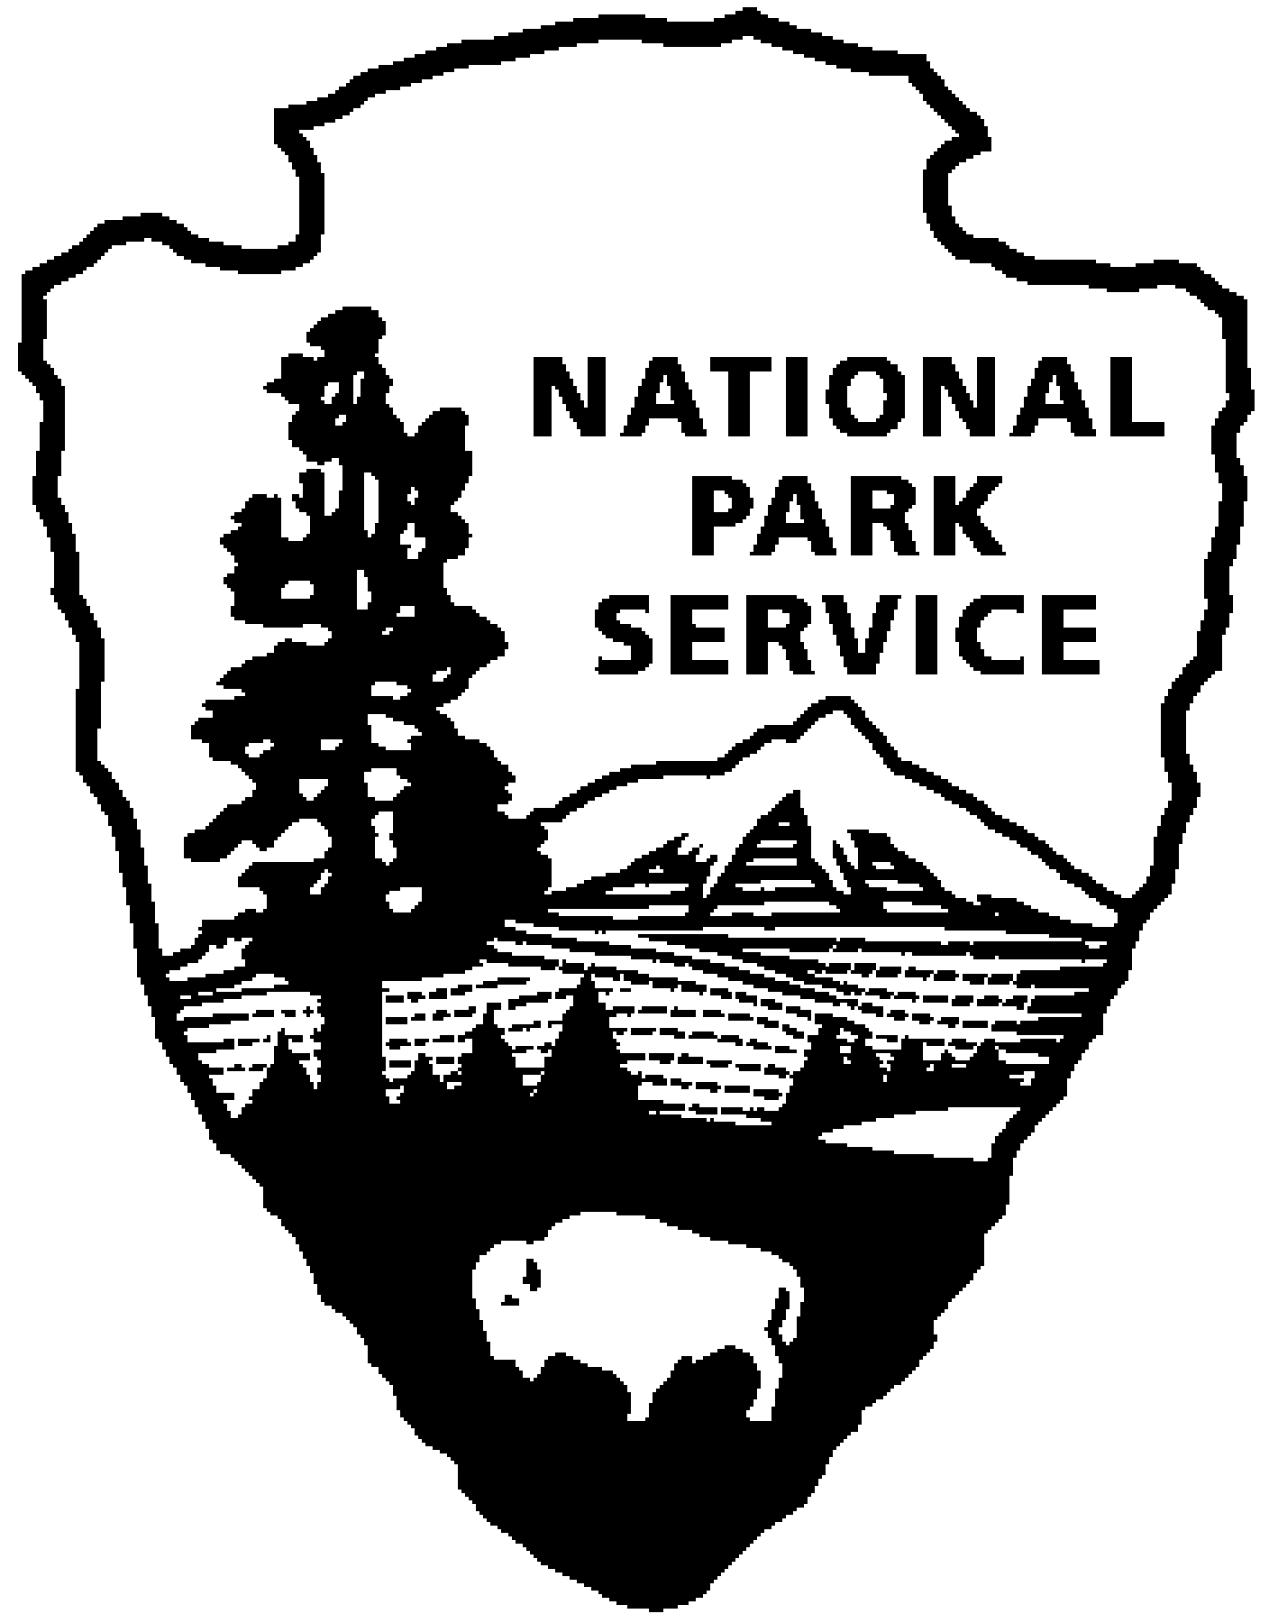
Zion National Park News Release
Use a “short-hand” version of the site name here (e.g. Palo Alto Battlefield not Palo Alto Battlefield National Historical Site).
October 9, 2007
For Immediate Release
David Eaker 435 772-7811
Brent Woffinden 435 772-0188
07-32

Pine Valley Peak Prescribed Fire in Zion to Continue

According to Superintendent Jock Whitworth, Zion National Park plans to continue ignition of a 1,549 acre section of the Pine Valley Peak Prescribed Burn Unit on Thursday, October 11, 2007. Approximately 750 acres of this section of the burn was completed on October 3. Weather conditions then forced the park to halt further ignitions for that week. The area was previously burned in smaller segments during 1999 and 2000. This prescribed fire project is located on the west side of the park, along the Kolob Terrace Road

The project will begin with a blacklining operation along the Kolob Terrace Road, followed by ignition of portions of the interior of the unit. Once an area is ignited, it will actively burn for 3-5 days and then smolder for an extended period. The fire will be closely monitored by park personnel until declared out. Specific management goals associated with this second entry burn are to continue to apply fire to the landscape thus maintaining the natural role fire plays in this ecosystem and to maintain boundary protection by reducing excess hazardous fuels.

Short-term impacts will be possible smoky conditions and the temporary closure of trails in the vicinity of the burn area. Forecasted weather conditions should provide good smoke dispersal, but there is potential for it to settle into the canyons during the night. The Wildcat Canyon Trail system (including access to the Subway and the Northgate Peaks Trail) and the Hop Valley Connector Trail will be temporarily closed during the burn and reopened as soon as it is safe to do so.

The goal of the prescribed fire program in Zion is to use management-ignited prescribed fire, where appropriate, for the restoration of fire-dependent ecosystems and species-specific resource management goals. Prescribed fire projects are to be conducted in a manner consistent with land and resource management plans, public health considerations, and approved prescribed fire plans. The park works very closely with other state and federal land management agencies in the planning and management of these fires. The policy of using fire as a tool will help decrease risks to life, property, and resources; prescribed fires will help perpetuate the natural resource values for which Zion National Park was established.

For more information about this or other prescribed fire projects in Zion, call 435-772-3256 or visit our website at www.nps.gov/zion.

